Sunday 7th September 2025

Lesson 18

IWA

**Class room - Worksheet walkthrough** **2**

**Question 1** **2**

**Question 2:** **3**

**Question 3** **4**

**Question 4** **4**

**Question 5** **5**

**Question 6** **5**

**Question 7** **6**

**Question 8** **6**

**Question 9** **7**

**Question 10** **8**

**Question 11** **9**

**Question 12** **9**

**Question 13** **10**

**Question 14** **10**

**Question 15** **11**

**Question 16** **11**

**Question 17** **12**

**Question 18** **12**

**Question 19** **12**

**Question 20** **13**

**Question 21** **14**

**Question 22** **14**

**Question 23** **16**

**Question 24** **18**

**Question 25** **18**

**Question 26** **19**

**Question 27** **20**

**Question 28** **21**

**Question 29** **22**

**Question 29 working out** **22**

**Question 30** **22**

**Question 31** **22**

**Question 32** **23**

**Question 33** **23**

**Question 34** **23**

**Question 35** **24**

**Question 36** **24**

**Question 37** **24**

**Question 38** **24**

**Question 39** **25**

**Question 40** **25**

**Classroom theory** **25**

# Class room - Worksheet walkthrough

5357 - 003 Electrical Scientific Principles and Technologies /

2365-602 Principles of Electrical Science

# Question 1

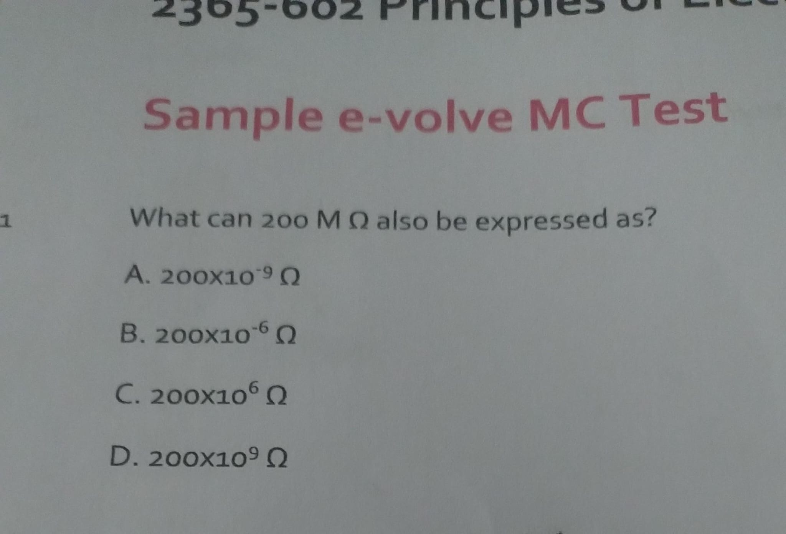

# Question 2:

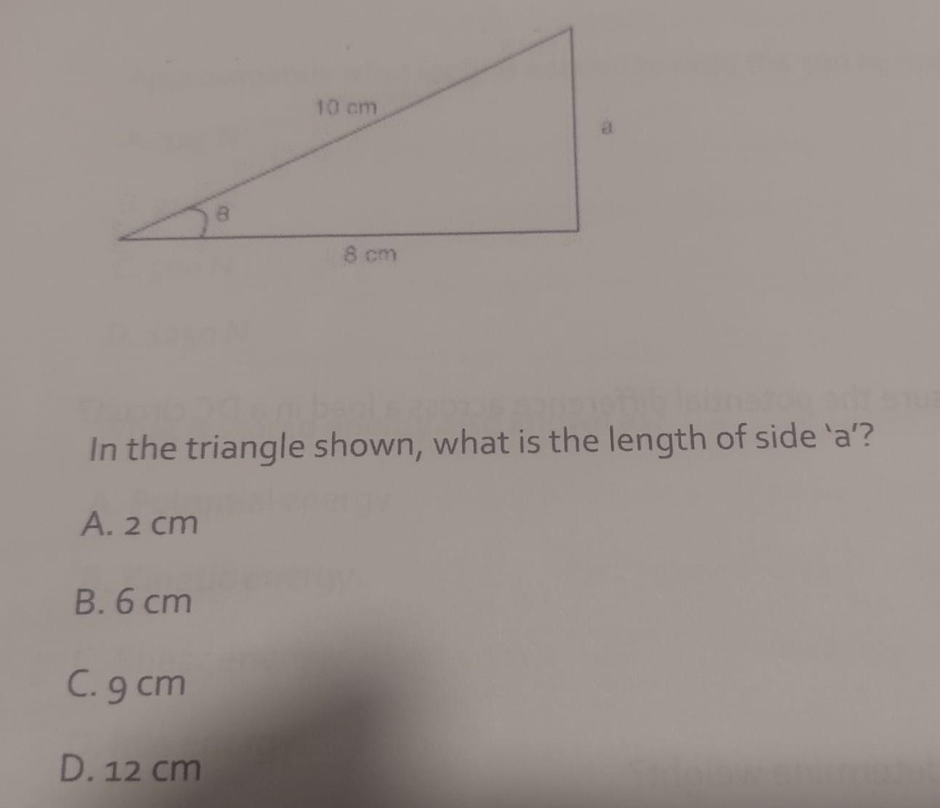

**Question 2 working out:**

**Foundation:**

***The formula a² + b² = c² is known as the Pythagorean theorem, which states that in a right-angled triangle, the square of the hypotenuse (the longest side) is equal to the sum of the squares of the other two sides (the legs).***

***This means that if you square the lengths of the two shorter sides (a and b) and add them together, you get the same value as squaring the length of the longest side (c).***

**Original source: google**

**Answer is 6 cm**

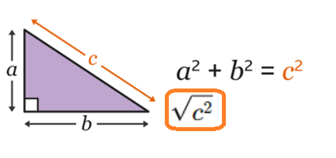

**C = The hypotenuse which is the longest side of the triangle.**

**a = 8 cm | c = 10 cm | b = ?**

1. **Following, the rule we know that performing the addition:**

* **a2 + b2 = c2**
* **a2 + b2 equates to c2**

**The question already gave us the value for c to be 10. So c2 = 100.**

**Therefore, a2 + b2 has to equal 100.**

**We already have a value for a to be 8 cm. So a = 8 cm.**

**82 = 64. Which is 36 away from 100. The square root of 36 is 6. Therefore the answer for b = 6 cm.**

# Question 3

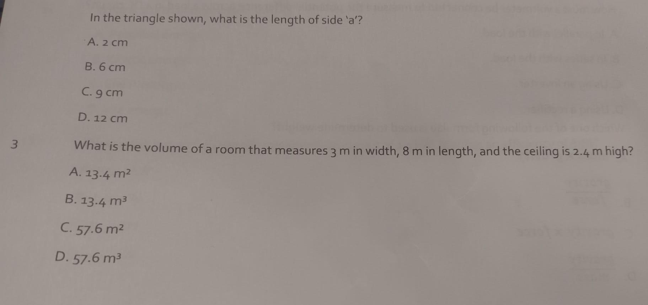

**Question 3 working out**

The answer is C.

Perform the multiplication 3 m x 8 m x 2.4 m = 57.6m2

# Question 4

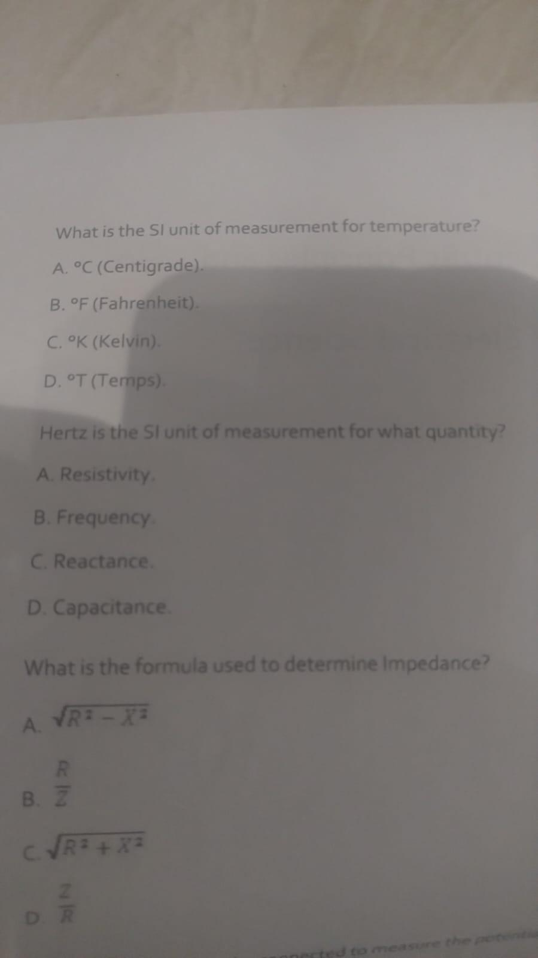

**Question 4 working out**

The answer is Kelvin

# Question 5

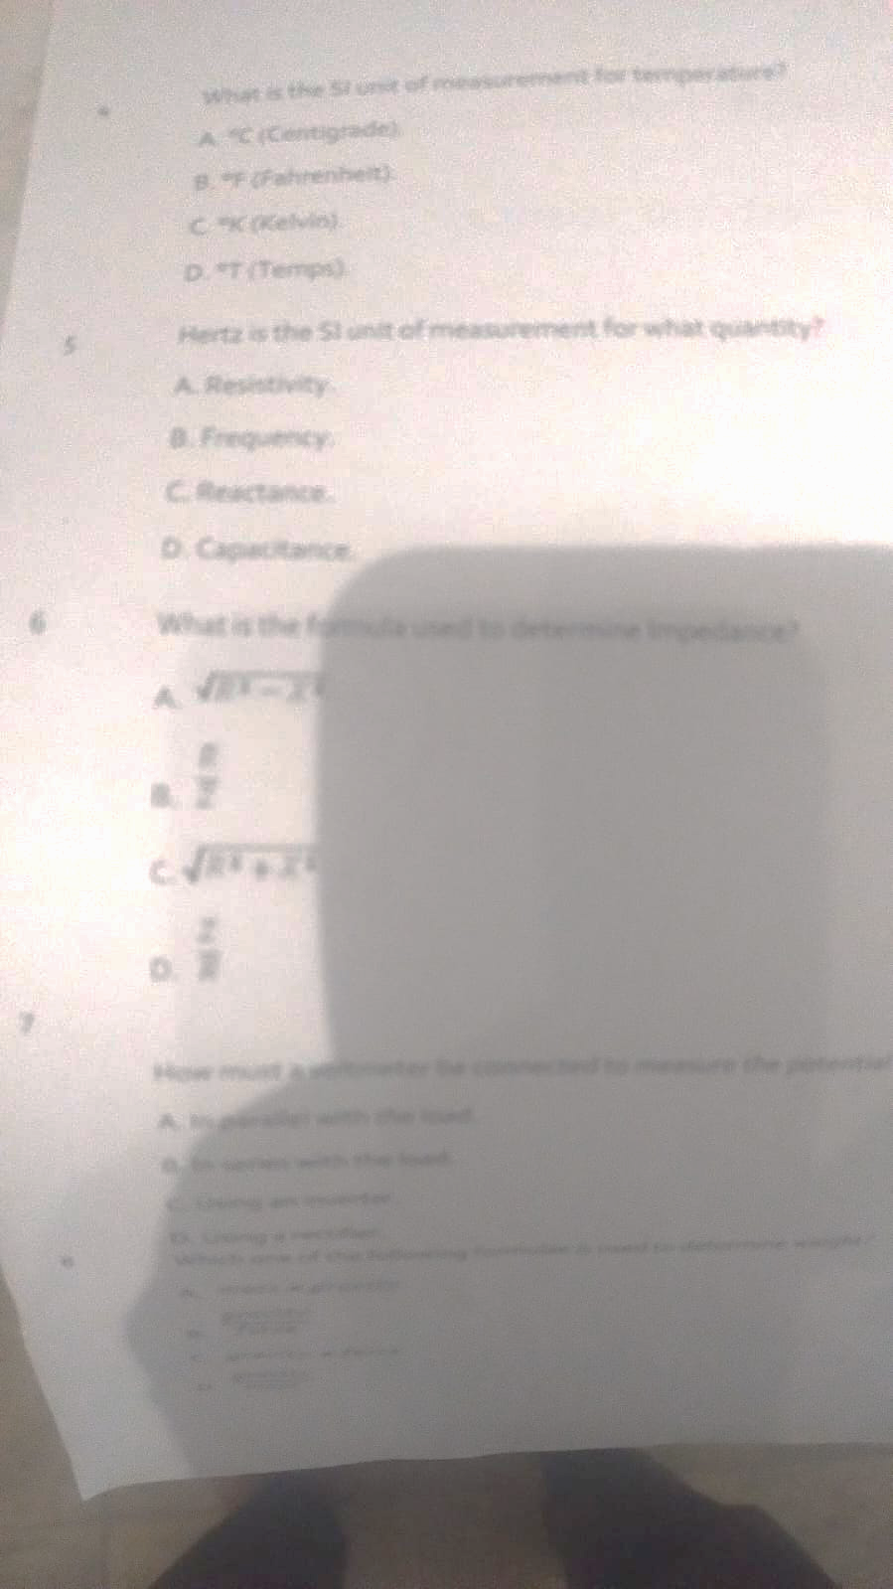

**Question 5 working out**

The answer is B frequency

# Question 6

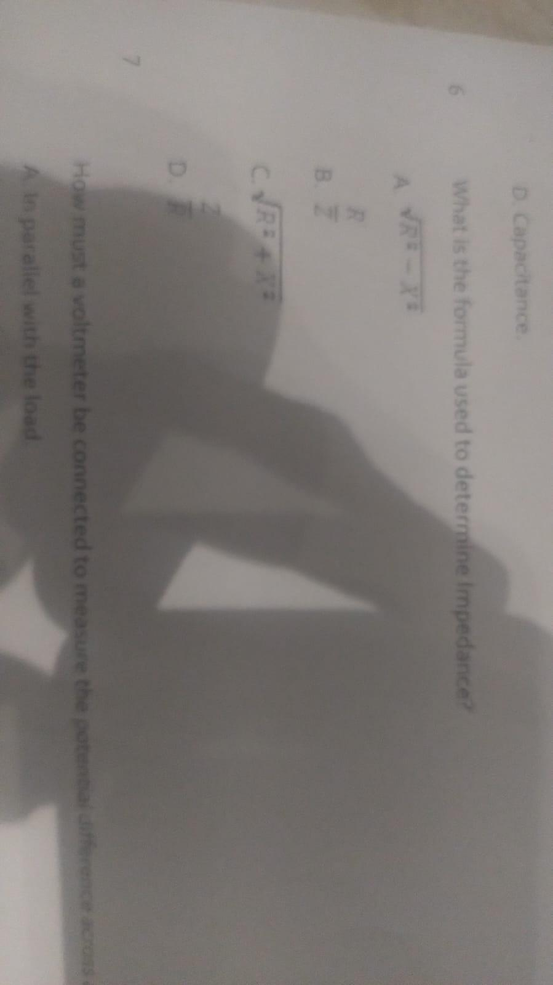

**Question 6 working out**

The answer is C

# Question 7

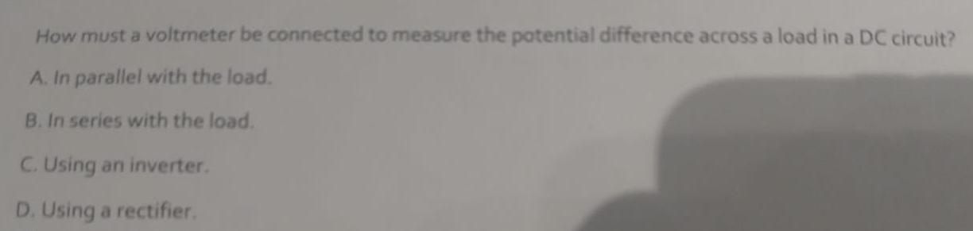

**Question 7 working out**

The answer is A

# Question 8

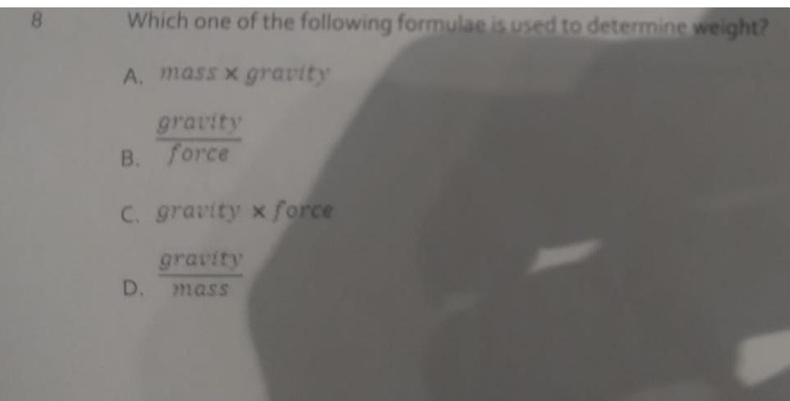

**Question 8 working out**

The answer is A) weight = mass x gravity

# Question 9



**Question 9 working out**

The answer is B) A lever

# Question 10

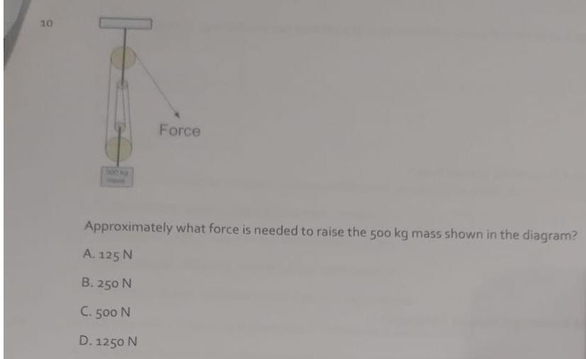

**Question 10 working out**

There are 4 pulleys (represented by four circles)

The weight is 500 kg.

The formula is: Force = Mass x gravity

4905 = 500 kg x 9.81

# 

# 

# Question 11

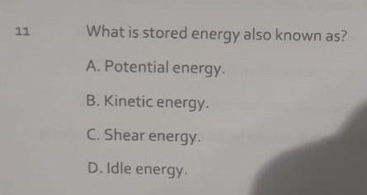

**Question 11 working out**

The answer is A) Potential energy

# Question 12

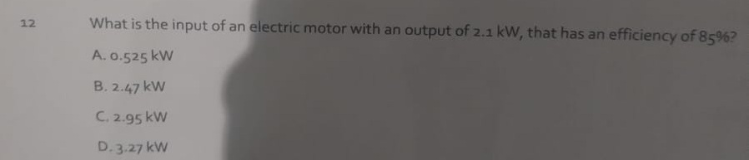

**Question 12 working out**

The answer is B => 2.1 / 0.85 = 2.47

# Question 13

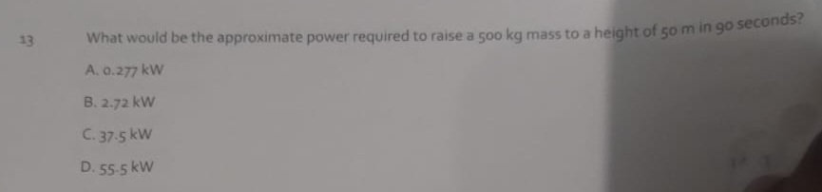

**Question 13 working out**

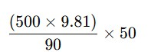

# Question 14

**Question 14 working out**

5 / 0.80 = 6.25 kW

# Question 15

# 

**Question 15 working out**

The answer is A) Protons

# Question 16

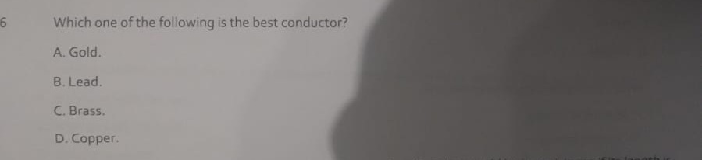

**Question 16 working out**

The correct answer is D) Copper.

Gold is also a conductor of electricity.

# Question 17

# 

The correct answer is A) 0.2 ohms.

When you half the distance you half the resistance.

# Question 18

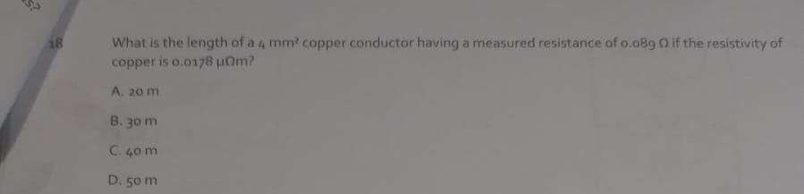

Question 18 working out

# Question 19

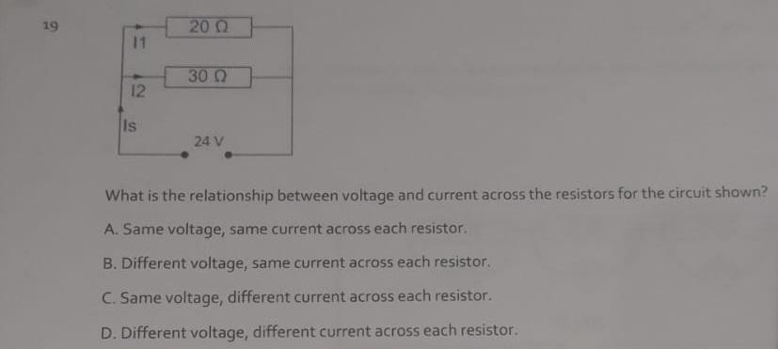

**Question 19 working out**

The circuit shown is a Parallel circuit.

The answer is D.

In a parallel circuit; the voltage is constant, the current differentiates.

In a series circuit; the current is the same and the voltage changes based on the resistors.

# Question 20

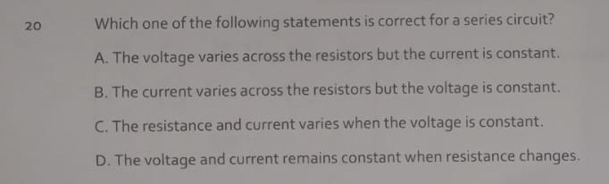

**Question 20 working out**

The answer is **A) The voltage varies across the resistors but the current is constant.**

# Question 21

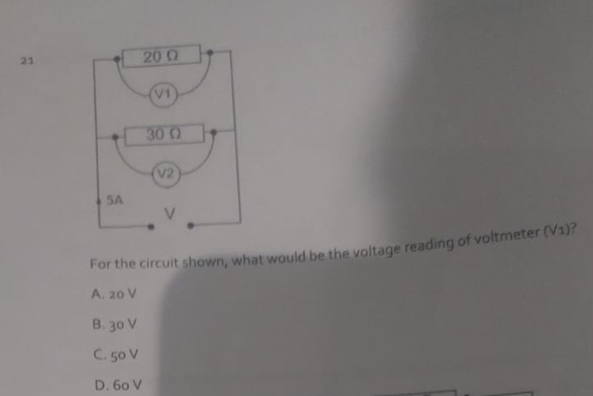

Question 21 working out

VIR formula triangle.

V = I x R.

Therefore, 5 A (the current is constant in a series) x 20 ohms of resistance -

# Question 22

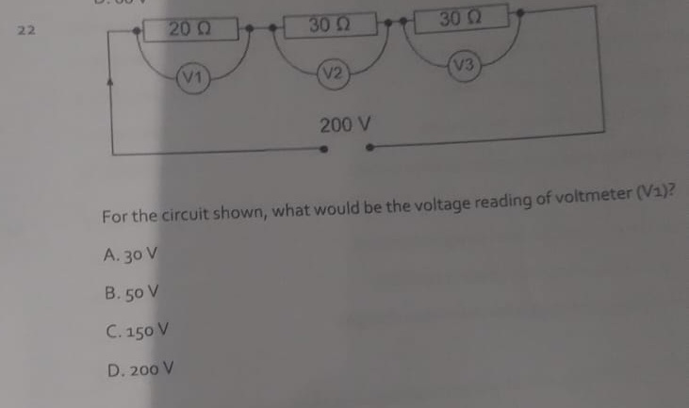

**Question 22 working out**

The answer is **B) 50 V.**

This circuit is a series circuit.

In a series circuit the current is constant and the voltage changes around the resistors.

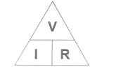

The **total voltage** is given as **200 V**.

We can calculate the **total resistance as** (**20Ω** + **30Ω** + **30Ω**) = **80Ω**.

We can then calculate the **total current** for the series circuit = **2.5 A.**

**I** = **V** / **R** => **2.5 A** = **200 V** / **80Ω**

The current of **2.5 A** is constant in a series circuit.

Then we do Ohms law around each resistor.

V1 = **2.5 A** x **20Ω** => **50 V**

V2 = **2.5 A** x **30Ω = > 75 V**

V3 = **2.5 A** x **30Ω = > 75 V**

# Question 23

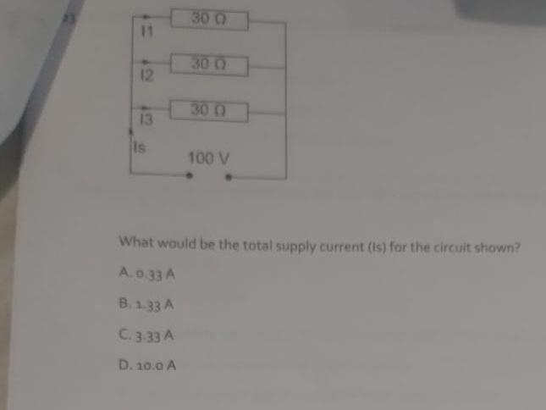

**Question 23 working out**

**VT** = 100 V

**IT** = ?

**RT** = ~~90Ω~~ (we do not add up the resistor/resistance values as we would do in a series circuit)

1/rt = 1/30 + 1/30 + 1/30

0.1 = 0.0333 + 0.0333 + 0.0333

0.1 => **10Ω** (multiply by 100)

**IT** = **100 V** / **10Ω**

**IT** = **10 amps**

In a parallel circuit; the **voltage** is constant and the **current** differentiates.

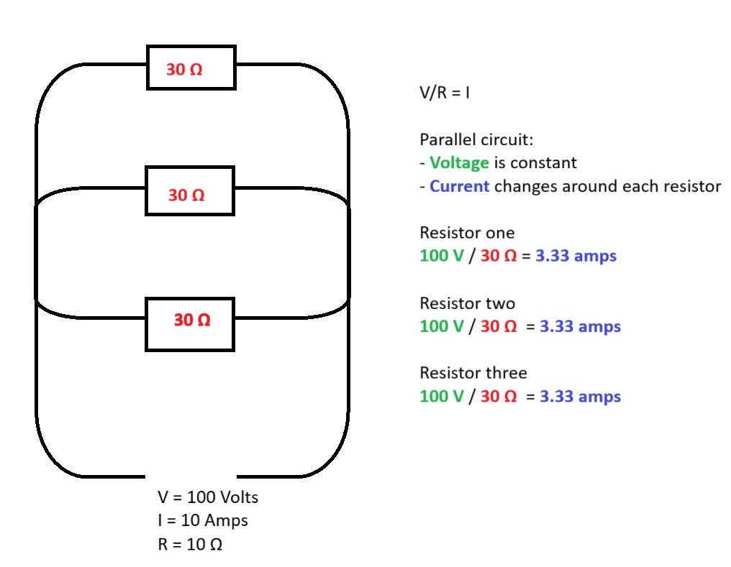

# Question 24

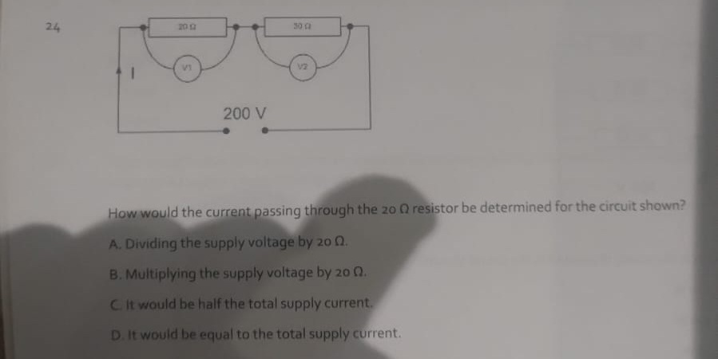

**Question 24 working out**

The answers is D

The **current** is constant in a series circuit and the **voltage** changes around the resistors.

**I** = **Voltage** / **Resistance**.

**200V** / **50 ohms Ω** = **40 amps**

# Question 25

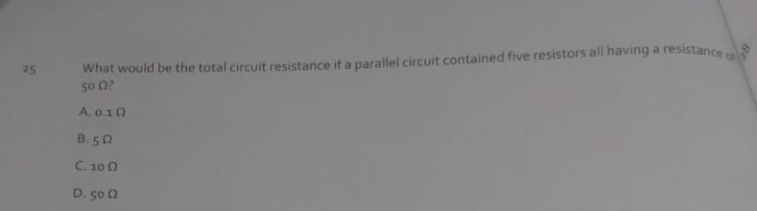

**Question 25 working out**

The answer is **C) 10 Ω**

The questions: “What would be the total circuit resistance if a parallel circuit contained five resistors all having a 50Ω?”

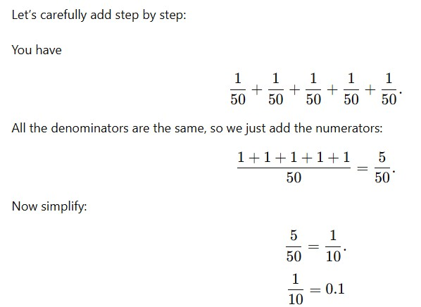

# Question 26

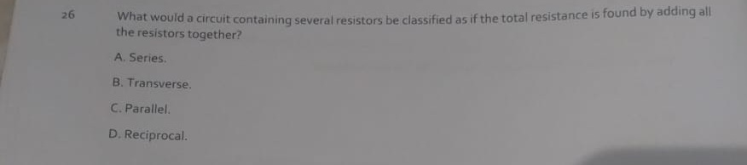

**Question 26 working out**

The answer is A) Series.

In a series circuit you can calculate the total resistance by adding all of the individual resistors together.

# Question 27

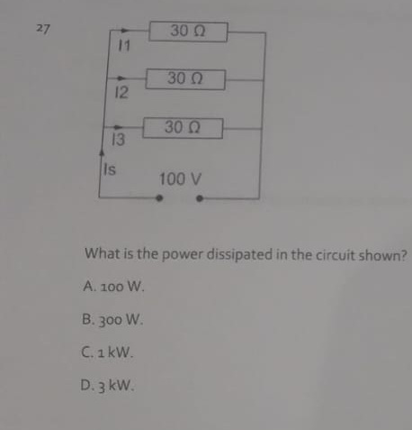

**Question 27 working out**

In a parallel circuit the **voltage** is constant. The **current** differentiates.

Whenever power is mentioned the formula to use is **PIV**. P = I x V.

The question provides us with the **voltage** and the information to calculate the total **resistance**. However, we need to use the VIR formula triangle first to get the I (**current**) in order to calculate the power.

**V** = **100V**

**I** = ?

**R** =>

1/30 + 1/30 + 1/30 = 3/30.

3/30 simplified = 1/10 => 0.1.

0.1 x 100 = **10Ω.**

**100V / 10Ω = 10 amps**

**V** = **100V**

**I** = **10 amps**

**R** = **10Ω**

Now we have the **current** and the **voltage** so we can deduce the **power**. Using the **power** formula triangle.

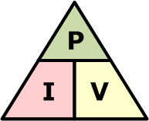

**Power = Current x Voltage**

**1kW = 10 amps x 100V**

# Question 28

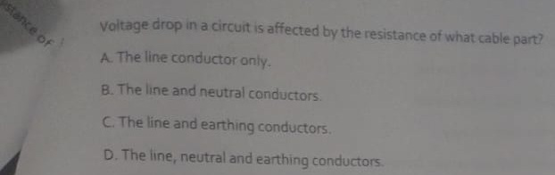

**Question 28 working out**

The answer is B

# Question 29

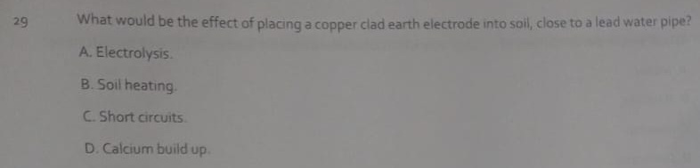

# **Question 29 working out**

The answer is A

# Question 30

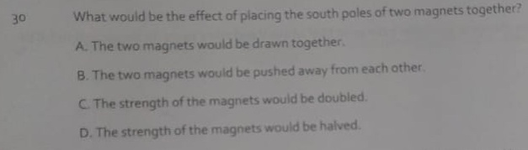

The answer is B

# Question 31

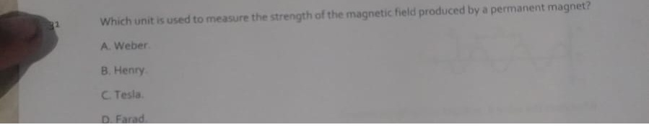

**Question 31 working out**

The answer is B

# Question 32

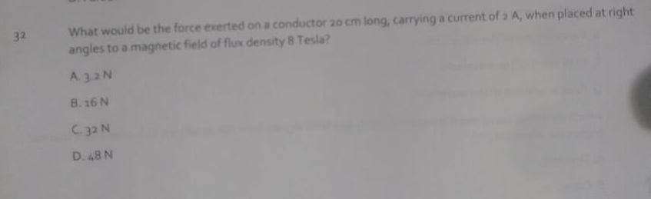

**Question 32 working out**

# Question 33

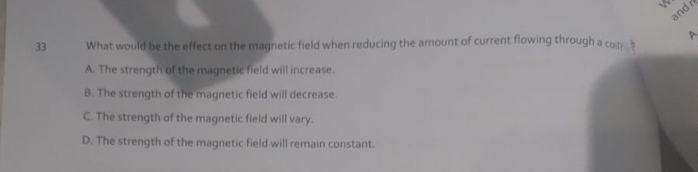

# Question 34

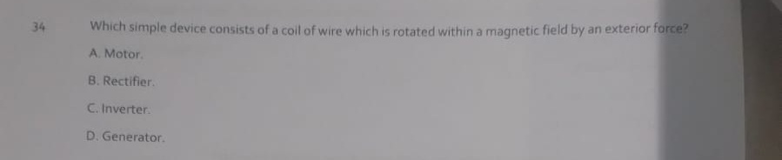

# Question 35

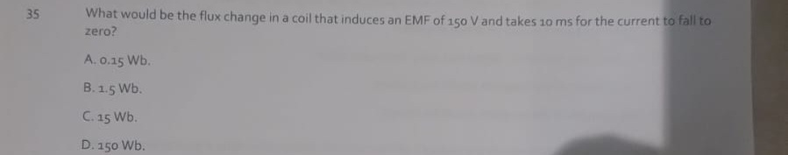

# Question 36

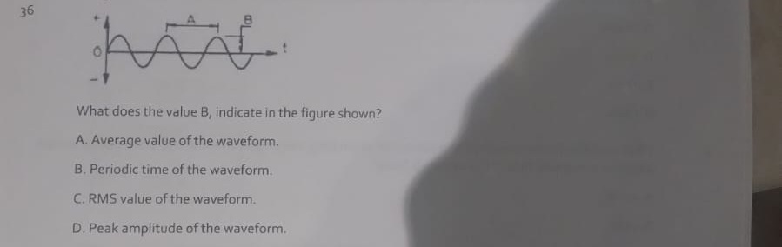

# Question 37

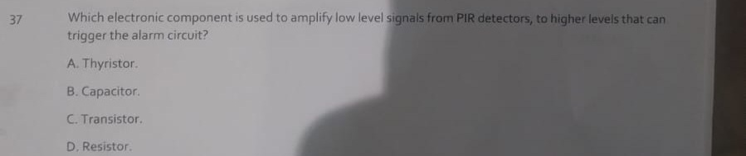

# Question 38

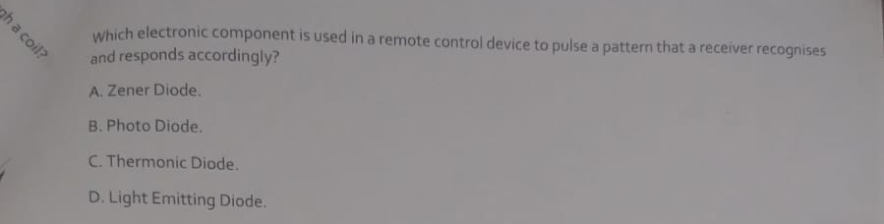

# Question 39

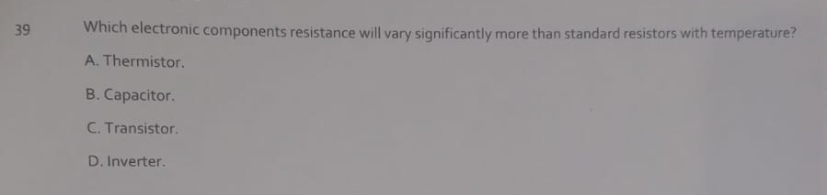

# Question 40

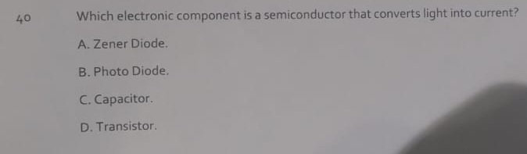

# Classroom theory

Mass never changes and stays the same.

Weight changes due to the impact of gravity. A person would have a different weight on earth compared to outer space.